**Inline**

Demonstrations of the Inline tag. Inline tags enable .x3d files to be embedded into another .x3d file using the <Inline> tag. Some developers appreciate the inline tag because they can break up an X3D scene into several smaller files, and even comment out parts of the scene.

**Inlinedemo01.x3d**

This example includes two inlined files. The panel textured with “North East West South” comes from **planemore.x3d**. The animated panel textured with the dog and the other panel with the red, blue and black pinwheel are from the file **animation01.x3d**.

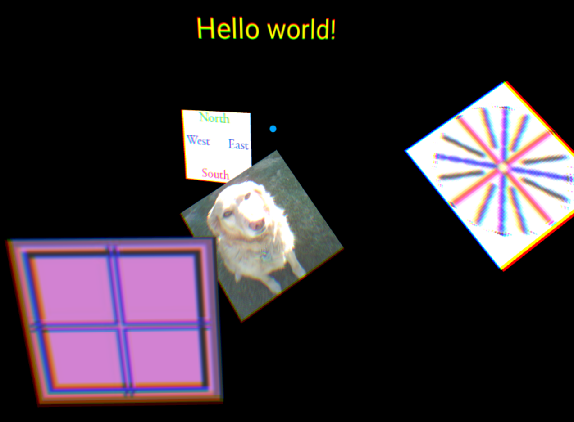

**levelofdetailusedef03.x3d**

Example uses Level of Detail to inline the different levels. The Text nodes are embedded in external files using X3D’s *<Inline>*, simulating how some developers apply Level of Detail switching to external files.

The Text is animated back and forward so that as it crosses past the panel textured with Marker ONE, changes from **text-lod-demo1.x3d** to **text-lod-demo2.x3d**.

**<LOD range='4 9'>**

**<Inline url="text-lod-demo1.x3d" />**

**<Inline url="text-lod-demo2.x3d" />**

**<Inline url="text-lod-demo3.x3d" />**

**</LOD>**

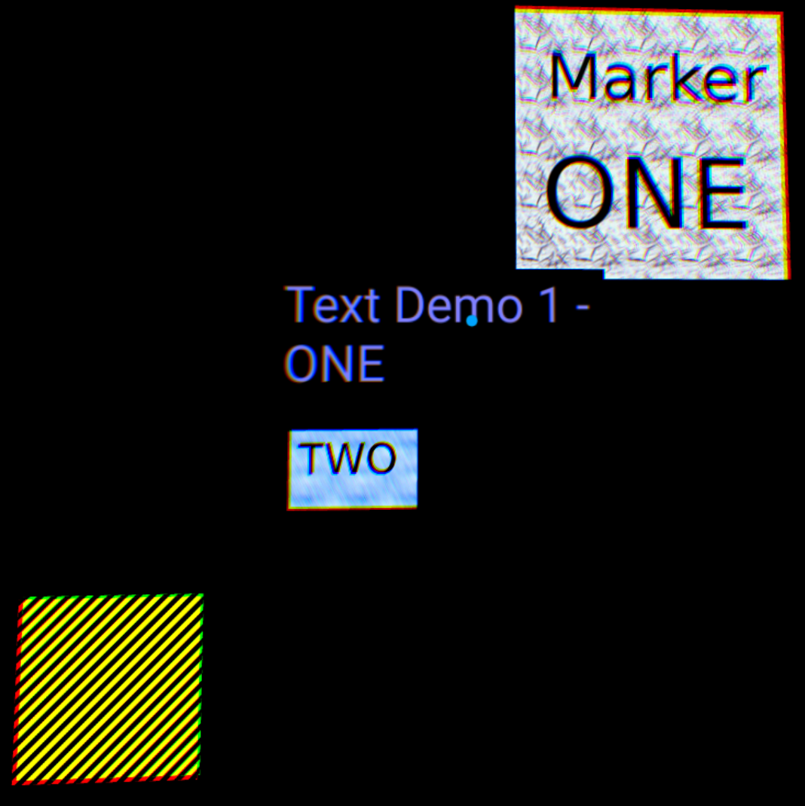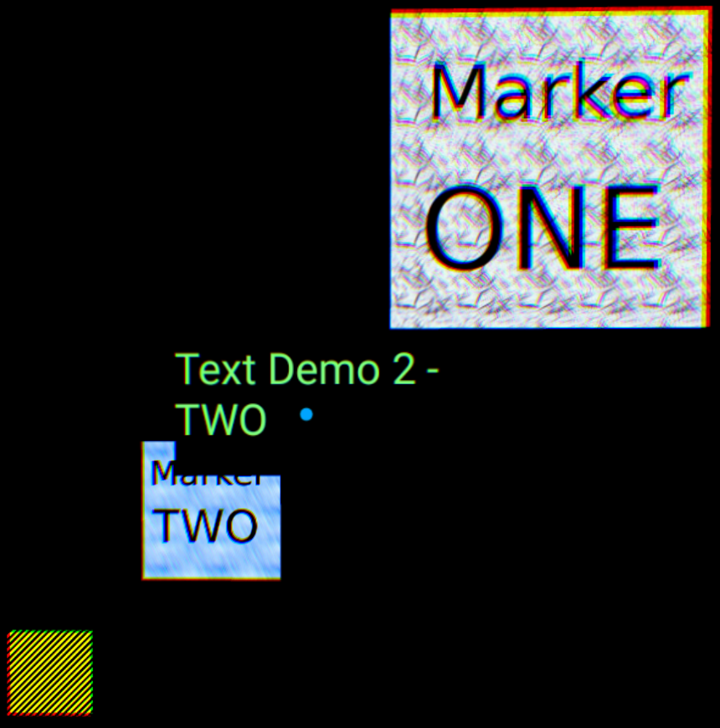

When the animation crosses Marker TWO, the text switches from the **text-lod-demo2.x3d** file to the third Inline, **text-lod-demo3.x3d**.

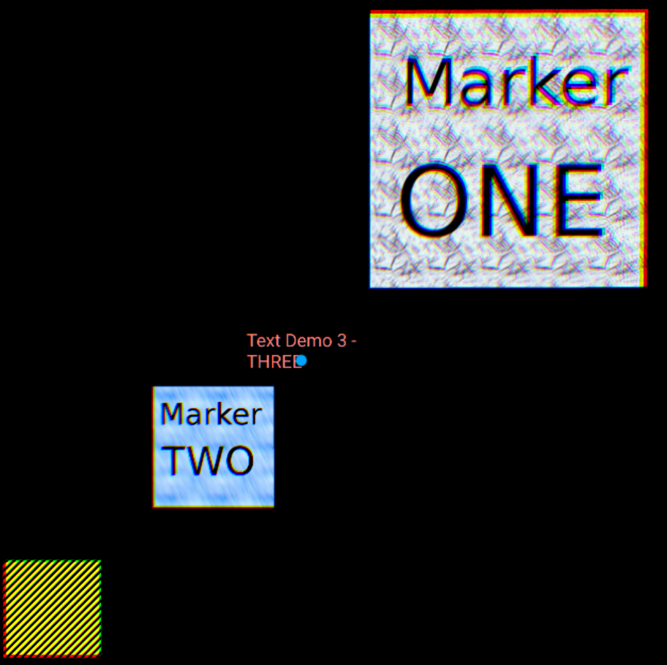

This scene includes an animated object with the texture map on the right. This is part of the main file and just adds some variety to the test.